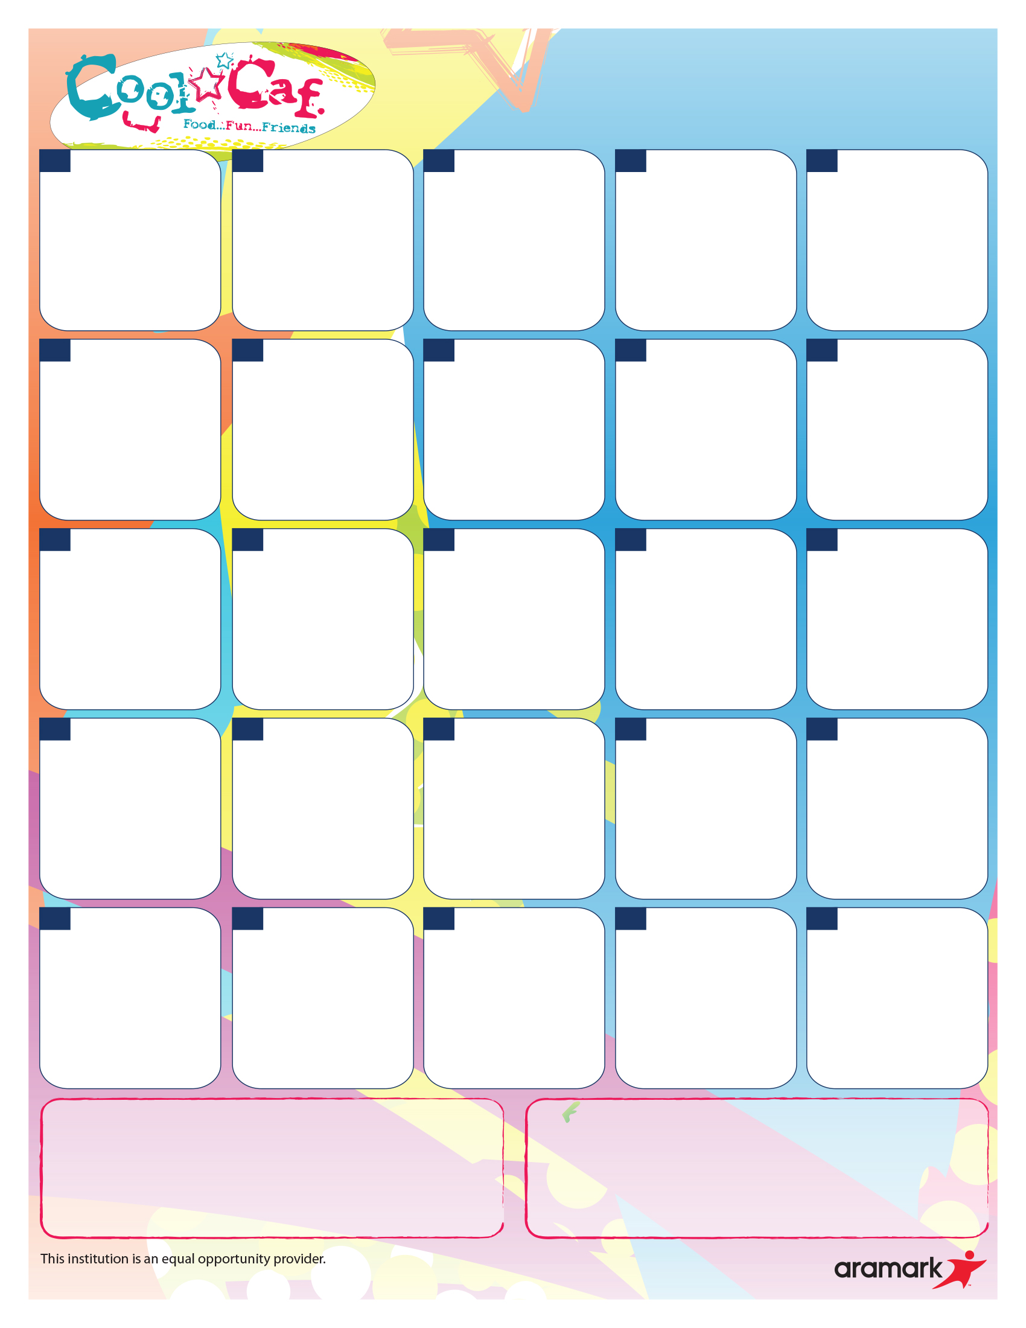

Fruit Cup Selection includes Applesauce, Fruit Cocktail, Diced Pears and Diced Peaches.

Egg and Cheese on Whole Grain Bagel

100% Juice

Fruit Cup

Egg and Cheese Sandwich

100% Juice

Fruit Cup

Egg and Cheese on Whole Grain Bagel

100% Juice

Fruit Cup

Chicken Sausage, Egg and Cheese on Whole Grain Bagel

100% Juice

Fruit Cup

Chicken Sausage, Egg and Cheese on Whole Grain Bagel

100% Juice

Fruit Cup

Pork Bacon, Egg and Cheese Sandwich on Whole Grain Bagel

100% Juice

Fruit Cup

**March 7th is Early Dismissal.**

Whole Grain French Toast Sticks, Chicken Sausage Patty

100% Juice

Fruit Cup

Egg and Cheese on Whole Grain Bagel

100% Juice

Fruit Cup

Whole Grain Pancakes

Chicken Sausage Patty

100% Juice

Fruit Cup

**Good Friday**

**No School**

Whole Grain Pancakes

Chicken Sausage Patty

100% Juice

Fruit Cup

Whole Grain Waffles

Chicken Sausage Patty

100% Juice

Fruit Cup

Whole Grain French Toast Sticks,

Chicken Sausage Patty

100% Juice

Fruit Cup

Pork Bacon, Egg and Cheese Sandwich on Whole Grain Bagel

100% Juice

Fruit Cup



Whole Grain Pancakes

Chicken Sausage Patty

100% Juice

Fruit Cup

Pork Bacon, Egg and Cheese Sandwich on Whole Grain Bagel

100% Juice

Fruit Cup

Pork Bacon, Egg and Cheese Sandwich on Whole Grain Bagel

100% Juice

Fruit Cup

**Breakfast is Free to All Students Attending Cohoes City Schools.**

Scrambled Egg and Cheese on Whole Grain Burrito

100% Juice

Fruit Cup

Scrambled Egg and Cheese on Whole Grain Burrito

100% Juice

Fruit Cup

In accordance with Federal law and U.S. Department of Agriculture policy, this institution is prohibited from discriminating on the basis of race, color, national origin, sex, age or disability. To file a complaint of discrimination, write USDA, Director, Office of Adjudication, 1400 Independence Avenue, S.W., Washington, D.C. 20250-9410, or call (866) 632-9992 (Voice). Individuals who are hearing impaired or have speech disabilities may contact USDA through the Federal Relay Service at (800) 877-8339; or (800) 845-6136 (Spanish). USDA is an equal opportunity provider and employer.

All breakfast meals are served complete with 100% Fruit Juice (Apple, Orange, Tropical and Grape) aw well as 1% White or Skim Milk. Additional Fruit is available as well. Adult Breakfast Price is $3.00 plus Tax. Adult Milk is $0.75 plus Tax.

**Cohoes City High School and Middle School**

**March 2024 Breakfast Menu**

Breakfast Pizza with Pork Bacon

100% Juice

Fruit Cup

Breakfast Pizza with Pork Bacon

100% Juice

Fruit Cup

**26**

**27**

**28**

**29**

**19**

**20**

**21**

**22**

**23**

**12**

**13**

**14**

**15**

**16**

**9**

**8**

**7**

**6**

**4**

**1**

If you have any questions regarding this menu please contact the Food Service Director, Brian Nolan at 518-237-9100 x 1411 or Email [BNolan@Cohoes.org](mailto:BNolan@Cohoes.org)

**11111**